Docs specify changing a few constants for the web and SG URLs:

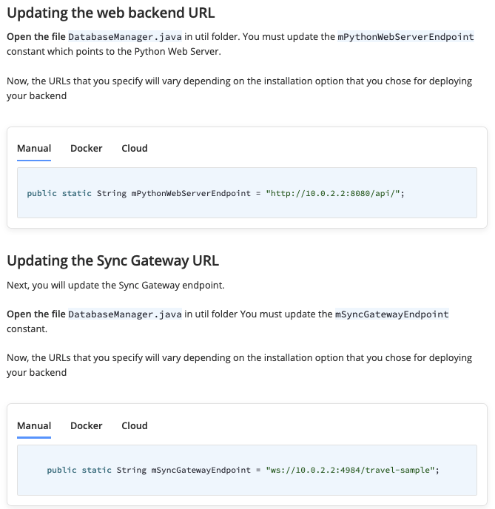

However the code doesn't have those exact constants:
